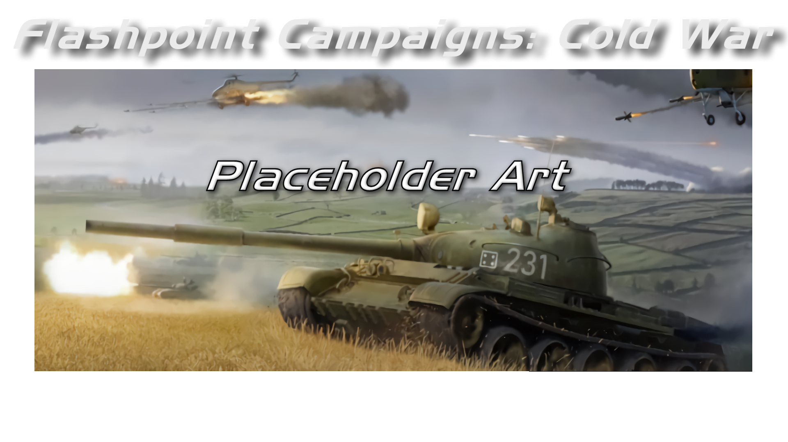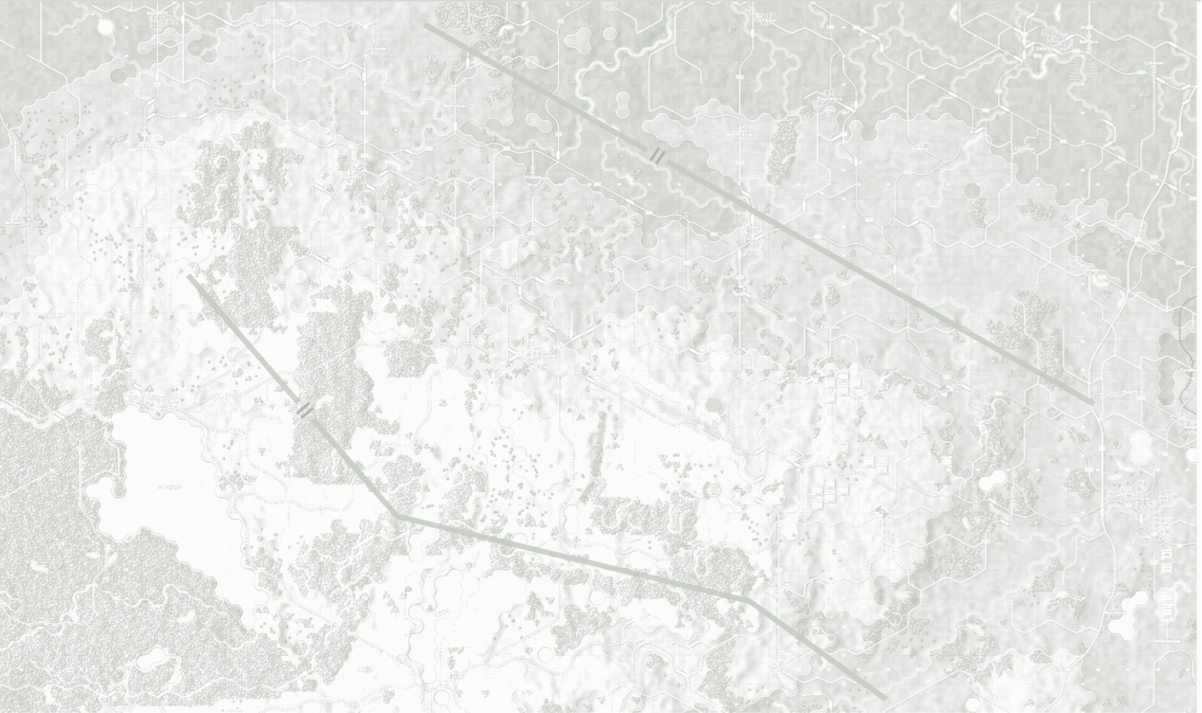

Hotkeys Summary

August 2025

**© 2025 On Target Simulations (OTS), LTD. All Rights Reserved. The images used and OTS Logo are property of On Target Simulations, LTD. All other marks and trademarks are the property of their respective owners.**

Table of Contents

1 Introduction 4

1.1 What's in This Document 4

1.2 Manuals 5

1.2.1 The Field Manuals (FM) 5

1.2.2 What’s New 5

1.2.3 FPC Hotkeys – This Document 5

1.2.4 Flashpoint Campaigns: Cold War FAQ 5

1.3 Gender Pronouns and Inclusion 5

2 Hotkey Use in Flashpoint Campaigns 6

2.1 About Rebinding Hotkeys 6

3 Hotkey Listings 7

3.1 Function Hotkeys 7

3.2 Current Shortcut Keys 7

3.3 Map Scale Hotkeys 8

3.4 Shift-Click for LOS Use 8

3.5 Selecting Multiple Units 8

3.6 Box-Selecting Multiple Units 8

4 Flashpoint Campaigns Credits 9

4.1 On Target Simulations 9

4.2 On Target Simulations Content Team 9

4.3 Cold War Beta Testers 9

4.4 Matrix Production Support 9

5 OTS on the Web 10

# A military tank in a field AI-generated content may be incorrect.Introduction

Welcome to FLASHPOINT CAMPAIGNS: COLD WAR

This is a grand tactical combat simulation on the Cold War battlefield. As the force Commander, you will plan and then issue orders and Standard Operating Procedures to your battalion, brigade, or regimental forces shaping the fight by maneuver and your intent. Your forces will engage the enemy on rendered real-world map locations. Each hex is 500m of militarily significant terrain. Each battle can last 4 to 24 hours of in-game time. Your troops will meet their foes any time of day and in any environment.

The game engine is based on asynchronous WEGO turns. This means you will issue orders and then watch a variable amount of time unfold on the battlefield. Then issue or adjust orders to react to what has happened as you execute your battleplan.

***Flashpoint Campaigns: Cold War*** is a deep simulation of combat operations where your forces are arranged in maneuver units of companies, platoons, and sections of tanks, infantry fighting vehicles, infantry squads and teams, recon forces, engineers, air-defense and anti-tank systems, helicopters and more. As the Commander, you must use available off-map assets like long-range artillery, rockets, or airstrikes.

Your efforts in this complex battlespace will be constantly challenged by modeled features like Electronic Warfare, Air Superiority, Realistic Weather, Line of Sight and Fire, Terrain and Elevation, Smoke and Mines, and Human Factors like training, morale, and readiness. All these elements must be considered if you are to be victorious on the battlefield.

The game is packed with information dialogs, map overlays, and range rings to aid you as Commander, master the situation, and understand your force’s capabilities.

***Flashpoint Campaigns: Cold War*** is a data-rich simulation where each nation has information on National Characteristics, Command Parameters, and Orders of Battle. Data Tables are packed with era-specific equipment and troops. Weapon Systems of the time, such as guns, missiles, precision munitions, small arms, and much more, are comprehensively modeled.

As a toolkit, you can create your own scenarios and campaigns. You can also dive deeper and create or modify game data, artwork, and sound effects as you see fit. All these modding capabilities are supported by detailed documentation.

* 1. What's in This Document

This document covers all the items you need to know to install, register, uninstall this game and what hardware and software you need to run it. Also, the names of all the fine folks who worked on this title and brought it to you are listed in the credits. The final item is the software license agreement to cover all the bases. If you are looking for how to run and use the game, refer to Section 1.2 below for a listing of game manuals.

**NOTE:** Areas of interest or buttons on form pictures are outlined in red.

**NOTE:** Some images in this manual are from other versions of the game. While your maps and units may be different, all the information and how it is used and displayed will match the information seen in this manual.

## Manuals

We have chosen to go with many living manuals to cover game interface/play, learning the game, basic tactics, Content Creation, and Game Modding for the Cold War game engine. We also have guides that cover that area of operations. The affected manuals and guides will be updated as the game is updated, and PDFs of these changes will be included with the new patches.

### The Field Manuals (FM)

These are the core manuals on how to play, create content for, and modify data for the Cold War game engine. Before jumping into Content Creation, we strongly recommend you review the first three manuals, **Game Operations**, **Battlefield Primer**, and **Tutorial Operations** if you are new to this type of game and warfare. Returning Flashpoint Campaigns players should review **Game Operations** to get details on new features, as there are many.

These documents are found in the Documents\FMs folder.

* FM01: Game Operations – Detailed information on the game, its interface, and how to use it
* FM02: Battlefield Primer – Fighting in the Cold War
* FM03: Tutorial Operations – How to learn and play the game
* FM04: Scenario Design – How to make or edit scenarios
* FM05: Battle Planning – How to create or edit battle plans
* FM06: Campaign Design –How to make or edit campaigns
* FM07: Map Construction –How to make simple maps for the game
* FM08: Game Engine Modifications - How to mod elements of the game engine
* FM09: Data Structures and Editing–How to edit or build data sets
* FM10: Weather Setup – How to add in weather from other locales

### What’s New

The What’s New PDFs summarize any changes and fixes when updates are released.

These can be found in the Documents\WhatsNew folder.

### FPC Hotkeys – This Document

This PDF document lists all the unique game key presses for Function keys and all hotkey definitions. There is no ability to rebind due to the large number of functions in the game.

This document is in \Documents folder.

### Flashpoint Campaigns: Cold War FAQ

To stave off forum-clogging threads on various topics that we either don't control or can't support, we have created this FAQ document with the answers to those specific topics.

Please review the FAQ for answers to several game topics related to the game but not on how to play the game.

This document is in the \Documents folder.

* 1. Gender Pronouns and Inclusion

We understand that our simulation will be played by users of all genders. We try to keep language in the game and manual gender neutral, when possible, but sometimes use the pronoun “he” to refer to the user. This is merely to streamline the writing and is not meant to exclude anyone or note a specific gender.

The On Target Simulations team supports the inclusion of all people in the field of wargaming.

# Hotkey Use in Flashpoint Campaigns

As with most software, Flashpoint Campaigns - Cold War (FCCW) has many predefined Hotkeys that substitute menu functions or speed button clicks to perform various actions in the simulation.

The following section shows the keys and effects currently supported. There are a few *Available* keys left in the listing, and new functions may be added in the future. Hotkeys are also noted in the various menus within the simulation.

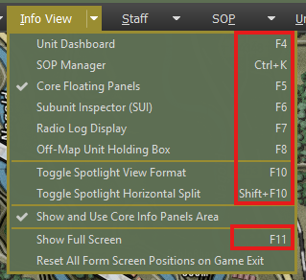

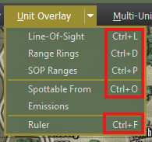

The in-game Help Menu can call up this document.

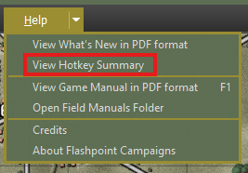

## About Rebinding Hotkeys

Due to the nature of the code, the colossal number of hotkeys, and how deep all these hotkeys are embedded in many functions and procedures, there is currently no way to rebind keys within the game.

If there is a means to make this dynamic in the future, we will revisit the code and look at what it might take to work.

# Hotkey Listings

The following sections cover the Function Keys, Shortcut keys, and Map Scale Hotkeys.

The information has the following format:

**KEY** – Game Function (Any information) [Speed button name]

## Function Hotkeys

**F1** - Open FM Folder (View Game Documents)

**F2** - Set User Preferences

**F3** - Show Game Difficulty Settings (Read Only)

**F4** – View Unit Dashboard

**F5** - Toggle Core Floating Panels On/Off

**F6** - View Subunit Inspector

**F7** - Toggle Radio/OOB Panel On/Off

**F8** - Toggle Off Map Assets (OMA) Panel On/Off

**F9** – Start/Pause/Resume Turn Resolution (In-Game Only)

**Shift+F9** - Replay Previous Turn Resolution (In-Game Only)

**F10** – Toggle between Spotlight View Formats

**Shift+F10** – Toggle between split and single Spotlight View Formats

**F11** - Toggle Between Full Screen Mode and Normal Window Mode

## Current Shortcut Keys

**Escape “esc”** – Pause game turn resolution, cancel the current Order in the Orders Phase, or if not in Orders mode, then cancel current active overlays.

**Num pad “+”** - Speed up game turn resolution (In-Game Only)

**Num Pad “-”** - Slow down game turn resolution (In-Game Only)

**Ctrl+A** - Show all friendly paths [Paths]

**Ctrl+B** - Go back one unit in OOB Tree

**Ctrl+C** - Show % Cover on the map

**Ctrl+D** - Show Range Rings: Spottable, Spotting, Effective Weapon, Maximum Weapon, Command as appropriate for the selected unit [Ranges]

**Ctrl+E** - Show Map Elevations

**Ctrl+F** - Toggle Map Ruler On/Off

**Ctrl+G** - Toggle Map Markers (not kills or craters) on/off

**Ctrl+H** - Bring all HQ units to the top of Stacks

**Ctrl+I** - Toggle NATO Symbols on Counters On/Off

**Ctrl+J** - Toggle Large NATO Symbols on Counters On/Off

**Ctrl+K** - SOP Manager

**Ctrl+L** - Show LOS area [LOS]

**Ctrl+M** - Show/Hide Modified Combined Obstacle Overlay (MCOO)

**Ctrl+N** - Go to the next unit in OOB Tree

**Ctrl+O** - Spottable From Overlay

**Ctrl+P** - Show unit movement path

**Ctrl+Q** - Toggle Sound Effects on/off

**Ctrl+R** - Rotate stack

**Ctrl+S** - Select stack

**Ctrl+T** - Show hex movement hindrance ratings

**Ctrl+U** - Clear map of units

**Ctrl+V** - Hide all victory point markers

**Ctrl+W** - Show hex Concealment ratings

**Ctrl+X** – Chain-of-Command Overlay

**Ctrl+Y** - Show sighted enemy by the selected unit

**Ctrl+Z** – Full Map Screen Capture

## Map Scale Hotkeys

**Ctrl+3** - Scale map at 130%

**Ctrl+2** - Scale map at 120%

**Ctrl+1** - Scale map at 110%

**Ctrl+0** - Scale map at 100%

**Ctrl+9** - Scale map at 90%

**Ctrl+8** - Scale map at 80%

**Ctrl+7** - Scale map at 70%

**Ctrl+6** - Scale map at 60%

**Ctrl+5** - Scale map at 50%

**Ctrl+4** - Scale map to Fit current screen size

**NumPad 5** – Center map on the active unit (to map edge limits)

## Shift-Click for LOS Use

With the LOS Overlay Tool active, you can select a unit with the mouse to see the line of sight overlay for that unit. You can also Shift-Click on an empty hex and see the basic line of sight from that location. You can select any number of hexes with the overlay tool active.

## Selecting Multiple Units

* **SHIFT-Click**: Holding down the Shift key while clicking any number of units will select those units. This selection helps give an order to the selected group. You can also Shift-Click on selected units to unselect them.
* **ALT-Click**: Holding down the Alt key and selecting an HQ unit will automatically select all subordinate units to that HQ. If you select a high HQ, all HQs under that command and all subordinates will be highlighted.
* **CTRL-CLICK**: Holding down the Ctrl key and selecting a unit will automatically select all of the unit's siblings and their local HQ.

Units in red boxes are currently selected with the yellow edges on the right and bottom of the unit counters.

## Box-Selecting Multiple Units

To select a group of units with the mouse, hold the CTRL key and move the mouse around the units to select holding down the left mouse button. A shadow box with white dashed outline will appear and any units in or on the outline get selected as seen below.

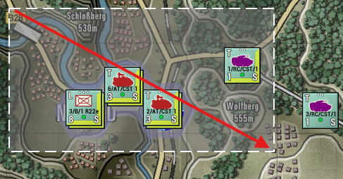

# Flashpoint Campaigns Credits

## On Target Simulations

* Lead Programmer and Head Honcho: **Robert "Ironman" Crandall**
* Data, Programming, Graphics, and Sound: **Jim "Cap’n Darwin” Snyder**
* Programming, Data, Models, and Research: **Jeff “Iron Mike” Sugden**
* Map Master, Programmer, AI, and Graphics: **William van der Sterren**
* Quality Czar and Testing Lead: **Charles “The Whip” Belva**
* Programming: **Kevin “SgtZDog” Zemon, Will Jackson, Alex Kriesel**
* Testing: **Tomasz Niedzinski**

## On Target Simulations Content Team

* Alexander “Stimpak” Schwarz, David “22sec” Whitt, Mike “MikeJ19” Johnstone, Joao Lima, Jurrie van der Zwaan, John “JohnO” Osborne, Jorgen “Jotte” Torgersson, Jo van der Pluym, Scott “WABAC” Gibbs and Steve “Mad Russian” Overton

## Cold War Beta Testers

* To be added before release

## Matrix Production Support

* **Erik Rutins, Maxim Klose-Ivanov**

# OTS on the Web

Matrix Games Forum: <https://www.matrixgames.com/forums/viewforum.php?f=10149>

Check Us Out on Discord: <https://discord.com/channels/911711314051739659/911711314257248331>

Check Us Out on Steam: *“Pending a page URL*”

**© 2025 On Target Simulations (OTS), LTD. All Rights Reserved. The images used and OTS Logo are property of On Target Simulations, LTD. All other marks and trademarks are the property of their respective owners.**